ROBIN ROBERTS PROMOTIONS
RULES FOR VENDORS

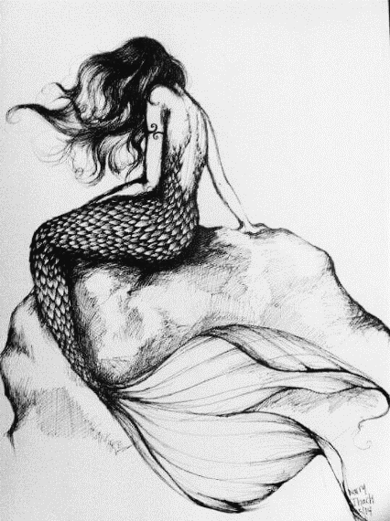
ELIGIBILITY: Only original arts and crafts will be approved for a show. Products imported, assembled from kits, or made from kits are not allowed. No items may be sold that have not been approved by Robin Roberts Promotions (RRP), and all products must be listed on the show application. No molded items may be shown or sold unless the originals were carved or sculptured by the exhibitor and have been approved by RRP prior to event. Robin Roberts Promotions reserves the right to reject any application or request any vendor to be removed at any time from a show with or without refund.

No commercial shops, stores, galleries, non-profit organizations or similar groups are allowed without a written exception from RRP. This excludes RRP Antique shows only.

CHARACTER OF EXHIBITS: All aisle spaces belong to the event. Displays will be confined to the outlined booth area, and must not exceed the designated area without permission from RRP.

Hand-written signage or “Sale” signs are not allowed. Displays must be presentable from all sides of the booth.

All tables must be covered in good taste and to the floor on all visible sides with flame retardant material. Table covers must be ironed and neat. Tables, chairs and all parts of booth displays must remain in the allotted booth space.

CARE OF EXHIBITS: Display spaces will be clean prior to booth set-up, and should be left in the same condition after the show. No trash, boxes or other debris should be left in the booth after the show.

The booth must remain intact until after the show closes on the last day of the event. Booths may not be shared or any part of the booth space sublet without the written consent of the RRP.

The registered vendor must be present during the hours the event is open unless previous approval has been given by RRP. Name badges will be supplied by RRP and must be worn during the show.

EVENT HOURS: The vendor must be ready for the show 30 minutes prior to the advertised opening time the event.

REMOVAL OF MATERIAL DURING SHOW: No vendor can break down or remove articles prior to the closing of the show without the permission and approval in writing from RRP. This rule does not apply to articles that have sold.

ELECTICAL POWER: Electrical power for booths must be requested on the show application at a cost of $25 per single outlet (single plug). Power during the North Georgia Highlands Seafood Festival is $35 per single 110 amp outlet or plug. No refunds will be given for electrical outlets ordered and not used.

LIABILITY: Exhibitors will be required to sign a hold harmless agreement at check-in, show a driver’s license, and provide vehicle (and trailer) information and tag number(s). The information provided will be verified, and any falsifications will resuls in automatic elimination from the show.

Vendors must provide their own public liability insurance and any other insurance they desire to cover exhibits, goods and personal belongings at their own expense

TAXES AND LICENSES: Vendors are solely responsible for obtaining all necessary licenses and permits and payment of any and all taxes, fees, licenses, permits, etc. RRP is not responsible for exhibitors licensing, fees, permits, taxes, etc.

SECURITY: RRP will provide reasonable security during the event and during hours when the event is closed. RRP is not responsible for losses or damages.

For security reasons, vendors should use only the designated exhibitors entrance at all times. No persons will be permitted in show area once show is closed.

SHOW MANAGEMENT: RRP strives to provide a show environment of courtesy and respect among all show participants. RRP Ambassadors and staff are an extension of Robin Roberts, and work to ensure a smooth-running show, answer questions, and resolve issues as they arise. Therefore, vendors who do not show respect for their fellow vendors or RRP staff will be asked to leave the show.

The following pertains specifically to outdoor shows:

TENTS AND WEIGHTS: Quality, fire-retardant, white-topped tents, such as Canopy, EZ-Up, and Flourish, are required for all outdoor shows. Use of tent tops other than white must be approved by RRP.

All tents must be weighted with 40 pounds of weight on each leg. Weights can be made from filled PVC pipe or purchased bag weights filled with water or sand. Five-gallon pails, cinder blocks, or gallon jugs are not acceptable. Weights should be tied to the tent infrastructure by woven strapping or nylon rope with a minimum diameter of 3/16 inches.

